DATA SCIENCE WITH PYTHON
Deep Learning Application in Data Science
A regularized residual neural network for monthly mortality forecasting
━━━━━━━━━━━━━━━━━━━━━━━━━━━━━━━━━━━━━━━━━━━━━━━
WEEK | 5
DATE | 16 August 2026
DATASET | Provisional COVID-19 Deaths by Sex and Age

Student name | Mandal Sahil Naushad
Institution | YuvaIntern
Public-use aggregate mortality data • Reproducible Python workflow

Report map
The document follows the required submission structure. Major sections are separated visually and use Word heading styles for navigation.
- 1. Title Page
- 2. Introduction
- 3. Dataset Overview
- 4. Methodology
- 5. Python Code Sections
- 6. Results and Findings
- 7. Visualizations (described in text)
- 8. Challenges and How They Were Handled
- 9. Discussion
- 10. Conclusion
- 11. References

2. Introduction
This report redesigns the Week 4 forecast as a residual neural-network problem. Instead of asking a network to learn the full count from scratch, it predicts a log-scale correction to the previous month's count. A zero correction exactly reproduces the strong persistence baseline, while positive and negative corrections represent expected growth and decline.
The CDC dataset remains appropriate because its 52 jurisdiction time series provide nonlinear lag, seasonal, and geographic relationships. It is also deliberately challenging for deep learning: only 2,069 feature-ready rows exist, so architecture size, regularization, and chronological validation matter more than adding layers.
Main outcome. The residual network improves the January–August 2023 test MAE from 48.892 to 34.253 deaths and raises R² from 0.732 to 0.867. The improvement comes from architecture aligned with the baseline, not from a large network.

3. Dataset Overview
Input preparation is carried forward from Week 4: All Sexes, All Ages, monthly records for 52 non-overlapping jurisdictions; September 2023 is excluded; three COVID lags, a three-month average, lagged all-cause and pneumonia counts, seasonal sine/cosine, time index, and one-hot state identity produce 61 input features.
Partition | Rows | Calendar period | Role
Fit | 1,381 | Apr 2020–Jun 2022 | Gradient updates.
Validation | 309 | Jul–Dec 2022 | Early stopping and learning-rate decisions.
Test | 379 | Jan–Aug 2023 | One-time future evaluation.
Table 1. Chronological deep-learning partitions.
The supervised target is log1p(current COVID deaths) minus log1p(previous-month COVID deaths). This residual is centered closer to zero and converts multiplicative changes into additive corrections. Evaluation is performed after adding the predicted residual to the log baseline and transforming back to death counts.

4. Methodology
The method defines the forecasting task, justifies the network architecture and hyperparameters, trains with explicit overfitting controls, evaluates four metrics, and diagnoses where the network still fails.

Step 1 — Preserve the Week 4 leak-free features
No current-month mortality measure is an input. Numeric preprocessing is fit on the 2020–June 2022 fit set only, and state categories are one-hot encoded with unknown-category handling. The validation and test arrays are transformed with the fitted training parameters.

Step 2 — Use a residual target and skip-path logic
The previous-month count is a strong forecast in smooth periods. The output layer is initialized to zero, so the untrained model begins at that baseline after the skip addition. This is safer than a random full-count prediction and focuses capacity on changes the baseline misses.

Step 3 — Choose a compact architecture
The network has Dense(32) → Dropout(20%) → Dense(16) → Dropout(15%) → Dense(1), with ReLU hidden activations and a linear correction output. The taper from 32 to 16 compresses interactions among 61 inputs without creating a large parameter count; the complete model has only 2,529 trainable parameters.

Why ReLU, linear output, and Huber loss
ReLU keeps positive hidden activations non-saturating and is a better fit than sigmoid here because the hidden representation is not a probability and standardized inputs can span both signs. Tanh could represent signed activations but saturates at large magnitude. A linear final unit is required because the correction can be positive or negative. Huber loss with delta 0.3 behaves quadratically near small residual errors but linearly for large wave shocks, reducing the influence of extreme transitions compared with mean squared error.

Step 4 — Address overfitting directly
L2 weight penalty 0.001 discourages large coefficients, dropout randomly removes 20% then 15% of hidden activations during training, and early stopping restores the lowest validation-loss weights after 20 non-improving epochs. Adam uses learning rate 0.001, batch size 64, and ReduceLROnPlateau. The regularized network's best epoch is 4 and training stops at 24.

Step 5 — Create an unregularized reference
I trained the same dense widths for 160 epochs without dropout or L2. Its best validation loss occurs at epoch 1; by the final epoch training loss is 0.01497 while validation loss is 0.49378, a gap of 0.47881. This is direct evidence that the dataset is too small for unconstrained fitting.

Step 6 — Evaluate against the same baseline
The final 2023 test uses MAE, RMSE, R², and WAPE on original death counts. The comparison baseline is exactly the previous-month forecast embedded in the residual architecture. Worst state-month errors are reported so an improved average cannot hide specific failures.

5. Python Code Sections

Code 1 — Imports, seeds, and chronological arrays
```python
import os
import random
import numpy as np
import pandas as pd
import tensorflow as tf
from sklearn.compose import ColumnTransformer
from sklearn.metrics import mean_absolute_error, mean_squared_error, r2_score
from sklearn.preprocessing import OneHotEncoder, StandardScaler
SEED = 42
os.environ["TF_DETERMINISTIC_OPS"] = "1"
random.seed(SEED)
np.random.seed(SEED)
tf.keras.utils.set_random_seed(SEED)
# model_data and the real Week 4 feature names are created exactly as in Week 4.
fit_data = model_data[model_data["start_date"] < "2022-07-01"]
val_data = model_data[model_data["start_date"].between("2022-07-01", "2022-12-01")]
test_data = model_data[model_data["start_date"].between("2023-01-01", "2023-08-01")]
```
Code explanation and output interpretation
- Deterministic seeds make weight initialization, dropout masks, and reported results repeatable within the same software/hardware setup.
- The split is chronological rather than random: 1,381 fit rows, 309 validation rows, and 379 future test rows.
- The test period is not used for architecture, stopping, or learning-rate decisions.

Code 2 — Fit preprocessing only on the fit period
```python
num_features = [
"lag1_covid", "lag2_covid", "lag3_covid", "rolling3_covid",
"lag1_total", "lag1_pneumonia", "month_sin", "month_cos", "time_index"
]
all_features = num_features + ["state"]
preprocess = ColumnTransformer([
("numeric", StandardScaler(), num_features),
("state", OneHotEncoder(handle_unknown="ignore", sparse_output=False), ["state"]),
])
X_fit = preprocess.fit_transform(fit_data[all_features]).astype("float32")
X_val = preprocess.transform(val_data[all_features]).astype("float32")
X_test = preprocess.transform(test_data[all_features]).astype("float32")
print(X_fit.shape, X_val.shape, X_test.shape)
```
Code explanation and output interpretation
- Fitting StandardScaler and the one-hot vocabulary only on the fit period prevents validation/test distribution information from entering preprocessing.
- Each transformed row has 61 inputs: nine numeric features and 52 jurisdiction indicators.
- Float32 reduces memory and matches TensorFlow's default numerical type without losing meaningful precision for these features.

Code 3 — Define the log-residual target
```python
y_fit = (
np.log1p(fit_data["covid_deaths"].to_numpy())
- np.log1p(fit_data["lag1_covid"].to_numpy())
).astype("float32")
y_val = (
np.log1p(val_data["covid_deaths"].to_numpy())
- np.log1p(val_data["lag1_covid"].to_numpy())
).astype("float32")
y_test = test_data["covid_deaths"].to_numpy(dtype="float32")
```
Code explanation and output interpretation
- A residual of zero means no change from the previous month; negative and positive values represent proportional decline and growth.
- log1p supports zero counts and reduces the difference between small and large jurisdictions.
- The final y_test remains on the original count scale because all reported metrics must have operational meaning.

Code 4 — Build the compact regularized residual network
```python
regularizer = tf.keras.regularizers.l2(1e-3)
model = tf.keras.Sequential([
tf.keras.layers.Input(shape=(61,)),
tf.keras.layers.Dense(32, activation="relu", kernel_regularizer=regularizer),
tf.keras.layers.Dropout(0.20),
tf.keras.layers.Dense(16, activation="relu", kernel_regularizer=regularizer),
tf.keras.layers.Dropout(0.15),
tf.keras.layers.Dense(
1, activation="linear", kernel_initializer="zeros", bias_initializer="zeros"
),
])
model.compile(
optimizer=tf.keras.optimizers.Adam(learning_rate=1e-3),
loss=tf.keras.losses.Huber(delta=0.3),
metrics=[tf.keras.metrics.MeanAbsoluteError(name="mae_log_residual")],
)
print(model.count_params())
```
Code explanation and output interpretation
- The model contains 2,529 parameters, intentionally small for 1,381 fit rows.
- ReLU captures nonlinear lag interactions without the saturation of sigmoid; the linear output permits both upward and downward corrections.
- Zero output initialization makes the first forecast equal to the previous-month baseline before any correction is learned.

Code 5 — Train with early stopping and learning-rate reduction
```python
callbacks = [
tf.keras.callbacks.EarlyStopping(
monitor="val_loss", patience=20, min_delta=1e-5,
restore_best_weights=True,
),
tf.keras.callbacks.ReduceLROnPlateau(
monitor="val_loss", patience=10, factor=0.5, min_lr=1e-5,
),
]
history = model.fit(
X_fit, y_fit,
validation_data=(X_val, y_val),
epochs=250, batch_size=64, shuffle=True, verbose=0,
callbacks=callbacks,
)
best_epoch = int(np.argmin(history.history["val_loss"]) + 1)
print(best_epoch, len(history.history["loss"]))
```
Code explanation and output interpretation
- Validation loss is lowest at epoch 4, and training stops at epoch 24 after patience is exhausted.
- restore_best_weights ensures test predictions use epoch 4 rather than the overfit final epoch.
- ReduceLROnPlateau allows smaller adjustments if validation improvement stalls before early stopping.

Code 6 — Reconstruct count forecasts and compute four metrics
```python
log_correction = model.predict(X_test, verbose=0).ravel()
baseline = test_data["lag1_covid"].to_numpy()
pred = np.clip(
np.expm1(np.log1p(baseline) + log_correction), 0, None
)
metrics = {
"MAE": mean_absolute_error(y_test, pred),
"RMSE": mean_squared_error(y_test, pred) ** 0.5,
"R2": r2_score(y_test, pred),
"WAPE_pct": 100 * np.abs(y_test - pred).sum() / y_test.sum(),
}
print(metrics)
```
Code explanation and output interpretation
- The predicted correction is added to the log previous-month count, implementing the explicit skip path.
- On the future test, the network reaches MAE 34.253, RMSE 59.621, R² 0.867, and WAPE 26.825%.
- All metrics are calculated after inverse transformation, so errors are reported in deaths rather than abstract normalized units.

Code 7 — Train an unregularized reference for evidence of overfitting
```python
unregularized = tf.keras.Sequential([
tf.keras.layers.Input(shape=(61,)),
tf.keras.layers.Dense(32, activation="relu"),
tf.keras.layers.Dense(16, activation="relu"),
tf.keras.layers.Dense(1, kernel_initializer="zeros", bias_initializer="zeros"),
])
unregularized.compile(
optimizer=tf.keras.optimizers.Adam(1e-3),
loss=tf.keras.losses.Huber(delta=0.3),
)
ref_history = unregularized.fit(
X_fit, y_fit, validation_data=(X_val, y_val),
epochs=160, batch_size=64, verbose=0,
)
print(ref_history.history["loss"][-1], ref_history.history["val_loss"][-1])
```
Code explanation and output interpretation
- The reference removes dropout, L2, and early stopping while retaining the same dense widths and residual target.
- Its final training loss falls to 0.01497, but validation loss rises to 0.49378; lower training loss is not better generalization.
- The 0.47881 final gap and epoch-1 validation optimum provide direct evidence for keeping regularization and early stopping.

6. Results and Findings
Method | MAE | RMSE | R² | WAPE
Residual neural network | 34.253 | 59.621 | 0.867 | 26.825%
Previous-month baseline | 48.892 | 84.661 | 0.732 | 38.289%
Week 4 boosted model | 69.259 | 116.878 | 0.490 | 54.239%
Table 2. Same January–August 2023 holdout; lower error and higher R² are better.
The residual network reduces MAE by 29.94% and RMSE by 29.58% relative to the previous-month baseline. WAPE falls by 11.464 percentage points, and R² increases by 0.135. It also reverses the Week 4 model failure because its architecture cannot forget the baseline unless the learned correction moves it.
Largest remaining error | Actual | Prediction | Absolute error
Texas, Feb 2023 | 632 | 965.2 | 333.2
Florida, Jan 2023 | 991 | 685.2 | 305.8
North Carolina, Jan 2023 | 675 | 372.7 | 302.3
Texas, Jan 2023 | 1,109 | 835.6 | 273.4
California, Feb 2023 | 754 | 1,026.5 | 272.5
Table 3. The model improves average performance but still misses rapid transitions in large jurisdictions.
The error list is balanced between over- and underprediction around the January transition. This matters operationally: a smaller overall MAE does not remove surge risk. The model needs intervals, rolling recalibration, and external leading indicators before use for decisions.

7. Visualizations (described in text)
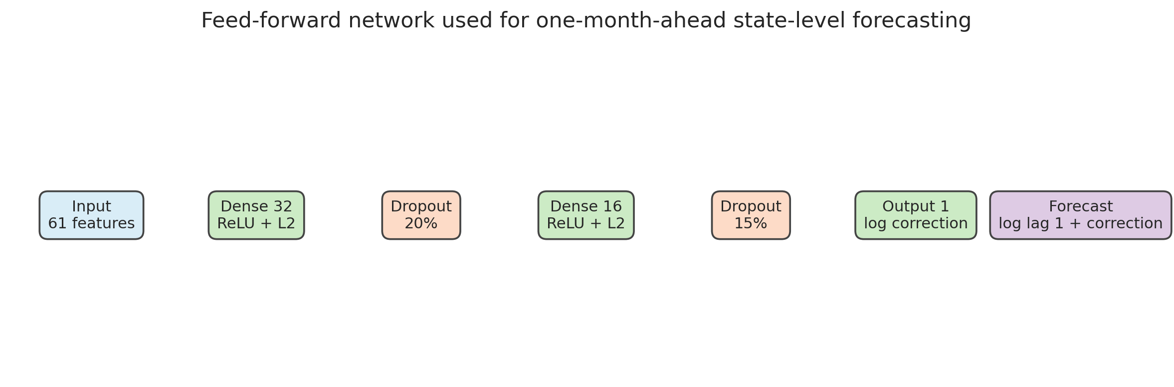
Figure 1. Compact residual network. The learned log correction is added to log1p(previous-month deaths) before inverse transformation.
Technical reading: 61 inputs flow through 32 and 16 ReLU units with dropout, then one linear correction. Analytical reading: the architecture allocates most responsibility to the proven previous-month estimate and asks the network only to model departures. This design is better matched to a small, persistent time series than a large unconstrained multilayer network.
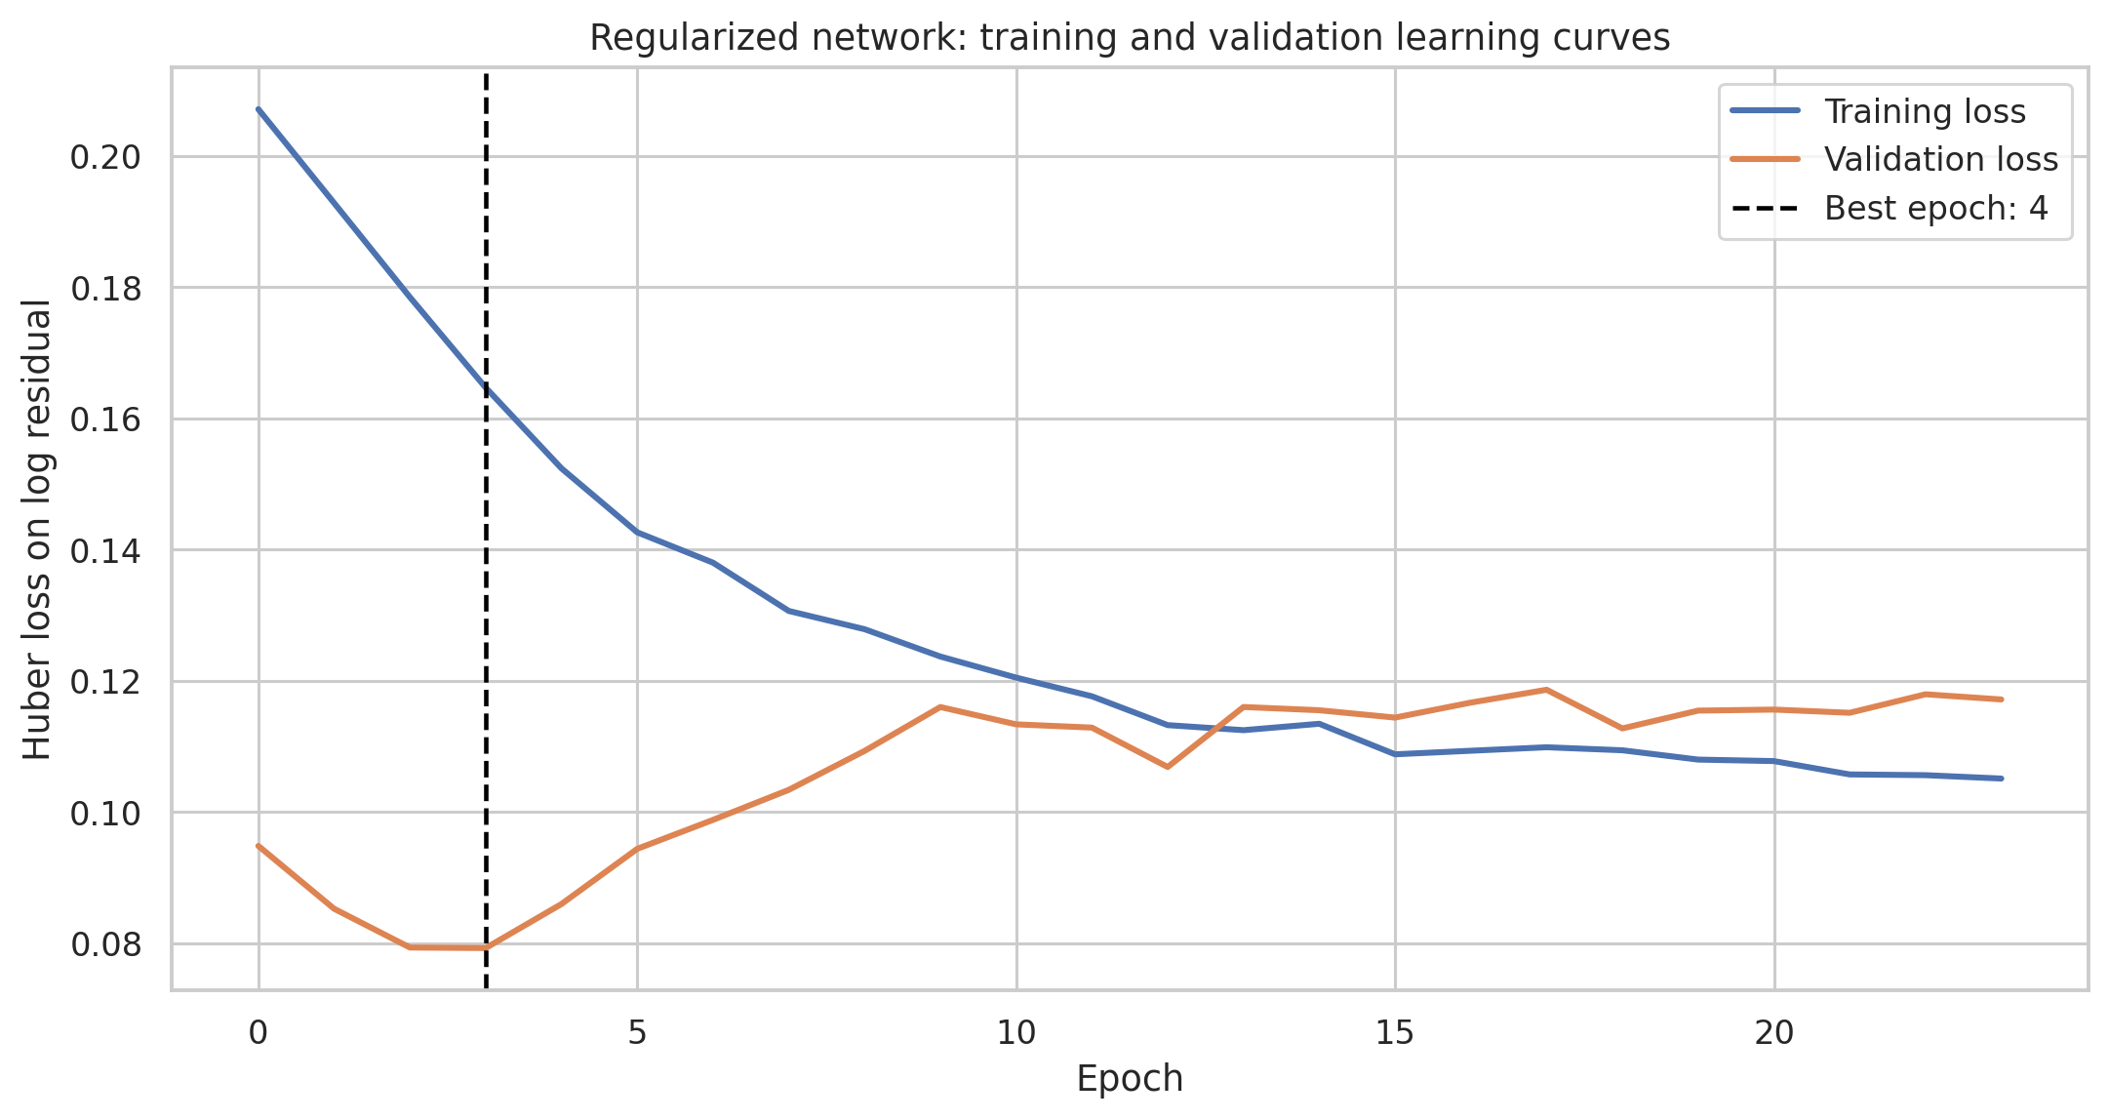
Figure 2. Regularized network training and validation Huber loss; best validation epoch is 4 and restored after stopping at epoch 24.
Technical reading: separate curves show optimization fit and future-period validation loss by epoch. Analytical reading: validation improvement occurs early; continued fitting mainly reduces training error. Early stopping prevents the later gap from being converted into test predictions.
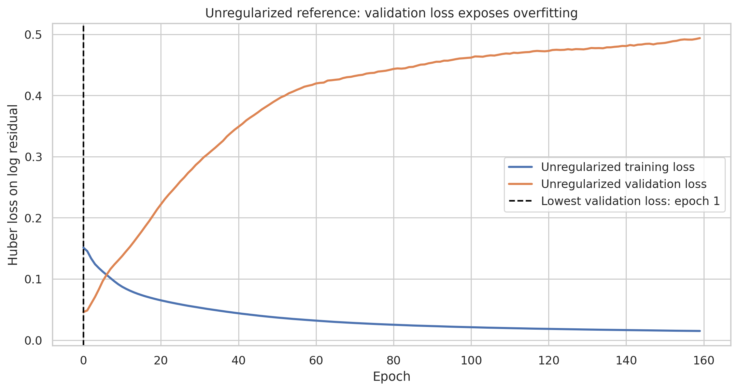
Figure 3. Unregularized reference training and validation loss over 160 epochs.
Technical reading: training loss continues downward while validation loss is lowest at epoch 1 and ends at 0.49378. Analytical reading: the network memorizes historical jurisdiction-wave combinations that do not transfer to late 2022. The divergence is evidence, not a generic warning, for regularization.
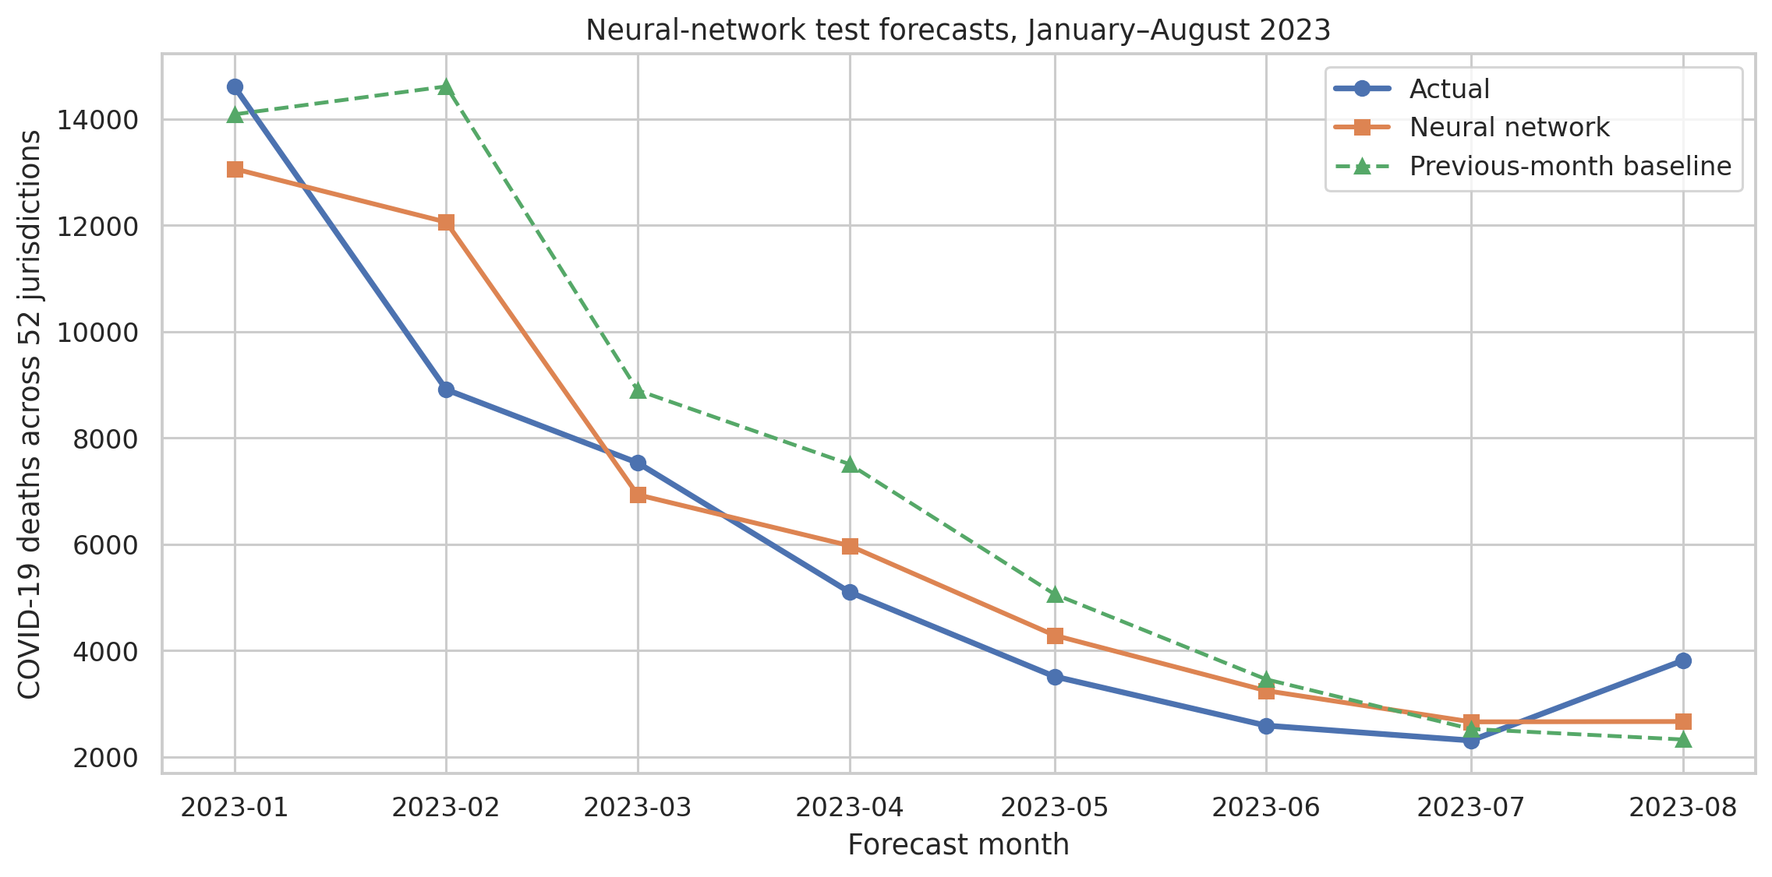
Figure 4. Aggregate neural, baseline, and actual test-period counts across scored jurisdictions.
Technical reading: monthly lines aggregate the same 379 observed state-month rows used for metrics. Analytical reading: the residual correction tracks the broad 2023 decline more closely than the lag baseline. The remaining January–February gaps align with the largest state-level errors.

8. Challenges and How They Were Handled
- The dataset is small for deep learning. I used two hidden layers and 2,529 parameters instead of a wide/deep architecture.
- A full-count network initially tended to underfit or overfit changing regimes. The target was redesigned as a log residual around the strong lag-1 baseline.
- Overfitting appeared quickly. Dropout, L2, chronological validation, early stopping, and a reference curve make the response measurable.
- Counts are extremely skewed across states and waves. log1p residuals, Huber loss, and original-scale evaluation reduce domination without hiding errors.
- CPU resources limit exhaustive tuning. A compact deterministic run and narrow, justified hyperparameter set are more reproducible than an unreported search.
- The model still makes large transition errors. Worst cases are listed, and no claim of deployment readiness is made without uncertainty intervals and live data.

9. Discussion
The architecture choice matters more than the label 'deep learning.' A generic network trained on full log counts performed poorly because the small sample spans major nonstationary regimes. The residual design begins from a useful forecast and learns modest changes. Zero initialization of the correction output is a practical safeguard: if training learns nothing, the model behaves like the baseline instead of emitting arbitrary counts.
ReLU is suitable in the hidden layers because the inputs are standardized and the objective needs sparse nonlinear interactions, not bounded probabilities. A sigmoid output would be wrong because corrections must be negative, while a linear output is appropriate. Huber loss protects training from wave shocks, but RMSE in evaluation remains important because planners still care about large misses.
Limitations remain: aggregate provisional data, no population or vaccination variables, only 44 complete months, interval-censored small counts, and a static source ending in 2023. TensorFlow randomness is controlled as far as practical, but exact floating-point results may vary across hardware. The model has no calibrated prediction intervals and may fail under a new variant or coding change.
If overfitting controls were skipped, the unregularized final validation loss shows what would happen: training performance would look excellent while future performance deteriorated. If the baseline were omitted, the network's positive R² could be celebrated without knowing whether it adds operational value. Both checks are essential.

10. Conclusion
A 2,529-parameter TensorFlow residual network improved the future holdout to MAE 34.253, RMSE 59.621, R² 0.867, and WAPE 26.825%, outperforming the previous-month baseline and the Week 4 boosted model. Training curves show the best validation result at epoch 4 and clear unregularized overfitting by epoch 160.
Week 6 will integrate the cleaning, EDA, clustering, boosted-model failure, and residual-network improvement into one pipeline. The recommended forecasting system will keep the lag baseline as a fallback, monitor rolling WAPE, and update from a current CDC source rather than the frozen 2023 extract.

11. References
- Centers for Disease Control and Prevention, National Center for Health Statistics. Provisional COVID-19 Deaths by Sex and Age. Dataset page: https://data.cdc.gov/National-Center-for-Health-Statistics/Provisional-COVID-19-Deaths-by-Sex-and-Age/9bhg-hcku
- CDC data download used for source verification: https://data.cdc.gov/api/views/9bhg-hcku/rows.csv?accessType=DOWNLOAD
- CDC WONDER provisional mortality access noted by the publisher as the successor source: https://wonder.cdc.gov/mcd-icd10-provisional.html
- McKinney, W. pandas: Python Data Analysis Library. https://pandas.pydata.org/
- Harris, C. R. et al. (2020). Array programming with NumPy. Nature, 585, 357–362. https://numpy.org/
- Waskom, M. L. (2021). seaborn: statistical data visualization. Journal of Open Source Software, 6(60), 3021. https://seaborn.pydata.org/
- Pedregosa, F. et al. (2011). Scikit-learn: Machine Learning in Python. Journal of Machine Learning Research, 12, 2825–2830. https://scikit-learn.org/
- Hunter, J. D. (2007). Matplotlib: A 2D Graphics Environment. Computing in Science & Engineering, 9(3), 90–95. https://matplotlib.org/
- Abadi, M. et al. (2016). TensorFlow: A system for large-scale machine learning. https://www.tensorflow.org/

